A Guide for Professionals Working with Hoosier Women
Hoosier women who are thinking about becoming pregnant, who are pregnant or have delivered a baby may apply for coverage for one of these Indiana Health Coverage Programs:
Healthy Indiana Plan (HIP) - HIP MAMA
- Adults 19 - 64 years old
- $23,628 (133% Federal Poverty Level + 5% disregard) for tax household of two (mom + baby)
- Pregnant women (pregnancy + 60 days postpartum) are placed into HIP MAMA with no cost sharing or POWER account payments during pregnancy
- Must choose a managed care entity (Anthem, CareSource, Managed Health Services, or MDwise)
Hoosier Healthwise
- For children and pregnant women (pregnancy + 60 days postpartum)
- For pregnant women: $36,936 (208% Federal Poverty Level + 5% disregard) for tax household of two (mom + baby)
- No cost for pregnant women
- Must choose a managed care entity (Anthem, CareSource, Managed Health Services, or MDwise)
Family Planning
- Services to temporarily or permanently prevent or delay pregnancy
- No age limitations
- Not eligible if pregnant
- Must not be eligible for other Medicaid programs.
- $17,614 (141% Federal Poverty Level) for tax household of one
- Not managed care
Note: Lawful Permanent Residents eligible for these Medicaid programs after 5 years.
Emergency Services Only
- Emergency services only (including labor and delivery)
- Available for immigrants who are otherwise eligible for Medicaid but lack qualifying immigration status.

Emergency Services Only with Pregnancy Coverage - Package B
NEW! Effective 11/30/2019
- Immigration status equal to “Lawful Permanent Resident”
- Pregnant or within the 60-day postpartum period
- Prenatal and postpartum services

Note: Newborns who live in Indiana are eligible for Hoosier Healthwise for 12 continuous months when their mother is enrolled in HIP, Hoosier Healthwise or Emergency Services the month of their birth.
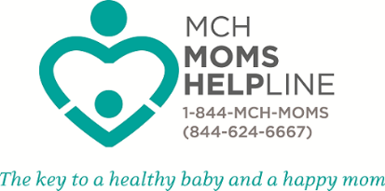
For additional resources for pregnant and postpartum women, contact the MOM’s Helpline. 844-624-6667.

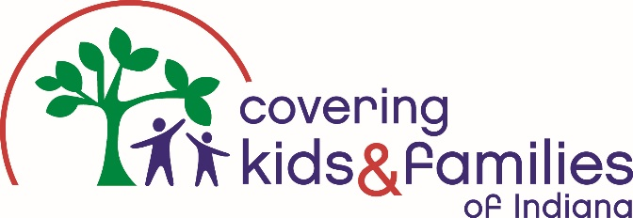
Pregnant women should meet with a Certified Indiana Navigator for assistance in signing up, utilizing and maintaining coverage. Call 800-589-2264 or visit mybrightpoint.org/CKF to connect to Covering Kids & Families of Brightpoint.

General Services
 | Family Planning | HIP & Hoosier Healthwise
Pelvic & breast examinations | X | x
HIV & STD testing Sexually transmitted infections (STI) | X | x
Initial diagnosis and treatment of sexually transmitted diseases (STDs) and sexually transmitted infections (STIs) | X | x
Screening, testing, counseling, and referral of members at risk for human immunodeficiency virus (HIV) | X | x
Ongoing follow-up of STDs and STIs and visits for treatment of chronic STDs and STIs |  | x
Long Acting Reversible Contraceptives -LARCs |  | x
oral contraceptives and sterilization | X | x
Opioid Treatment Programs |  | x
Hysterectomy |  | Medically necessary, not for sterilization

Prenatal Services (before baby is born)
 | HIP MAMA & Hoosier Healthwise
Prenatal tests and screenings | x
Screenings and treatment for hypertension, diabetes, high cholesterol | x
Prescription Drugs | X no copay when pregnant
Labor & Delivery | x
Lab tests | x
Hospital Care | x
Prenatal vitamins | x
Ultrasounds | Must be medically necessary
Genetic counseling, chronic villus sampling, amniocentesis | x
Infant care or parenting classes
Case management, | x
Substance abuse treatment | x
Prenatal home visits | x
Doula services | x
Licensed Birth centers | x
Home birth
Early elective deliveries

Postnatal Services (after baby is born)
 | HIP MAMA & Hoosier Healthwise
Screenings for postpartum depression | x
Postpartum home visits | x
Breastfeeding education services | x
Postpartum visits to doctor | X
Electric and manual breast pump | x
Lactation consultant services | Hospital based

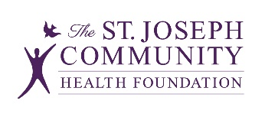
Sources: Office of Medicaid Policy and Planning Medical Policy Manual, Indiana Family and Social Services Administration Medicaid Policy Manual and Kaiser Family Foundation Medicaid Coverage of Pregnancy and Perinatal Benefits: Results from State Survey
Check out www.sjchf.org/picnetwork for easy online reference to materials presented today.

